Multi-Pipeline Employee Attrition Prediction with
Genetic Algorithm Feature Selection, Probability
Calibration, and Explainable AI

C. Guha
Department of Computer Science,
American International University Bangladesh,
Dhaka, Bangladesh
M.A. Uddin
Department of Computer Science,
American International University Bangladesh,
Dhaka, Bangladesh
S. Chakraborty
Department of Computer Science,
American International University Bangladesh,
Dhaka, Bangladesh

Abstract—Employee attrition is a costly and operationally disruptive problem for organizations. This paper proposes a leakage-controlled, multi-pipeline framework for predicting employee attrition using the IBM HR Analytics Employee Attrition dataset (Kaggle). Three pipelines are developed: (1) classical machine learning with tuned baselines (Logistic Regression, Decision Tree, Random Forest, XGBoost) and a soft-voting ensemble; (2) deep learning with baseline and KerasTuner-optimized artificial neural networks; and (3) a hybrid pipeline that combines genetic-algorithm (GA) feature selection with LightGBM, isotonic probability calibration, and recall-constrained threshold optimization for HR-sensitive decision-making. To prevent data leakage, preprocessing and SMOTE resampling are performed within cross-validation folds, and the held-out test set is evaluated once at the end. Explainability is provided using SHAP for global feature attribution and LIME for instance-level explanations. Experiments show that the tuned ANN achieves the best F1-score (0.579) with AUC-ROC 0.814, while the calibrated LightGBM offers strong interpretability and more reliable probabilities despite lower F1 (0.430). Overall, the study provides a rigorous comparison and a decision-oriented, explainable framework for trustworthy HR analytics.
Keywords—Employee attrition, HR analytics, machine learning, deep learning, genetic algorithm, LightGBM, probability calibration, threshold optimization, explainable AI.

Introduction (Heading 1)
Employee attrition, the voluntary or involuntary exit of employees remains a critical challenge for human resource (HR) management because it increases recruitment and training costs and can reduce productivity. Industry evidence suggests that replacing an employee can cost roughly one-half to two times the employee’s annual salary when direct and indirect costs are considered. In sectors with persistently high turnover, predictive analytics can help HR teams prioritize retention actions before preventable exits occur.
The IBM HR Analytics Employee Attrition dataset, hosted on Kaggle, is a widely used benchmark for attrition modeling. It contains 1,470 records with 35 attributes spanning demographics, job characteristics, and work history, with a binary attrition label (approximately 16% positive class). Despite extensive research, three recurring gaps remain: (i) evaluation bias caused by data leakage (e.g., applying scaling, feature selection, or resampling before data splitting), (ii) limited use of probability calibration when decisions depend on thresholds, and (iii) insufficient transparency of “black-box” models for HR adoption and governance.
This paper addresses these gaps by presenting a unified, leakage-safe experimental design with three isolated pipelines: classical ML, deep learning, and GA-optimized LightGBM, combined with calibration, recall-aware thresholding, and multilevel explainability. Our objectives are to: (1) develop and compare the three pipelines under identical leakage controls; (2) optimize decision thresholds subject to minimum-recall constraints for HR-sensitive use; and (3) produce actionable explanations using SHAP and LIME to support prescriptive retention insights.
Key contributions include:
- • A leakage-free architecture with fold-isolated preprocessing, SMOTE, and feature selection.
- • Integration of GA-based feature selection with gradient boosting to obtain compact, stable feature subsets.
- • Probability calibration and recall-constrained threshold tuning to improve decision reliability.
- • Comparative evaluation using F1, AUC-ROC, and Brier score, supported by explainable AI analyses.
- • Reproducible implementation and analysis to support future HR analytics research.

Related Studies
The literature on employee attrition prediction has evolved from statistical models to advanced AI techniques, driven by the availability of datasets like IBM's. We categorize the review into four areas: traditional machine learning approaches, deep learning applications, optimization techniques including genetic algorithms, and explainable AI in HR analytics. This section draws from 30 references to highlight gaps our framework addresses, such as leakage, calibration, and interpretability.

Traditional Machine Learning Approaches:

Early works focused on classical ML for attrition prediction. Wang and Zhi [13] developed a machine learning-based analytical framework for employee turnover prediction, emphasizing feature selection and imbalanced data handling to achieve robust performance. El-Rayes et al. [17] predicted employee attrition using tree-based models, highlighting the role of demographic and job-related features in HR contexts. Ahmed et al. [15] applied ML to employee performance prediction within administrative information systems, incorporating turnover indicators for practical applications. More recent studies incorporate HR-specific features. Akasheh et al. [12] conducted a systematic literature review on ML techniques for predicting employee turnover, identifying common models like Random Forest and XGBoost. Borse et al. [14] detected early warning signs of employee attrition using ML algorithms, focusing on behavioral patterns. Kambhampati and Rao [16] advanced employee attrition models through a systematic review of ML techniques and emerging opportunities. Pallathadka et al. [13] analyzed attrition in software companies, proposing reasons and measures using ML for retention strategies. Qutub et al. [28] predicted employee attrition using ML and ensemble methods, achieving improved accuracy in real-world scenarios. Alam et al. [29] proposed a ML approach to analyze and reduce features for employee turnover prediction models.

Deep Learning Applications:

Deep learning has gained traction for handling complex patterns. Gong et al. [10] integrated artificial intelligence in human resource management, reviewing DL applications for turnover prediction and future agendas. Gafni et al. [7] explored objectivity by design in AI-driven soft skills evaluation, impacting DL-based attrition models. Vakeel et al. [2] studied remote work in the metaverse, using DL to assess job satisfaction and retention factors. Bankins et al. [4] navigated career stages in the age of AI, incorporating DL for systematic interdisciplinary reviews on employee outcomes.

Optimization Techniques and Genetic Algorithms:

Optimization enhances model efficiency. Massaoudi et al. [22] introduced a novel stacked generalization ensemble-based hybrid LGBM-XGB-MLP model, demonstrating superior performance in imbalanced tasks relevant to attrition data. Zhang et al. [21] developed a stacking ensemble algorithm for improving biases in estimations, adaptable to employee turnover models. Castro-Lopez et al. [23] examined the role of entrepreneurial orientation and HRM in circular economy innovation, with optimization implications for retention strategies. Orero-Blat et al. [25] analyzed big data analytics capabilities for innovation in organizational performance, using multi-mixed methods for optimization.

Explainable AI in HR Analytics:

Explainable AI (XAI) helps address the opacity of high-performing models and is increasingly important for HR decisions that require justification and fairness. Hamja et al. [19] proposed an explainable attrition prediction system tailored to HR use. Ding et al. [18] surveyed XAI techniques and highlighted trade-offs between fidelity and interpretability. Recent reviews also emphasize governance and transparency requirements that parallel financial decision-making contexts [20]. In HR analytics, big-data–driven decision support must balance predictive performance with explainability and ethical considerations [9,24]. Accordingly, our framework integrates SHAP for global explanations and LIME for local explanations to support both organizational insights and case-level reasoning.
Gaps identified: Most studies overlook data leakage in ML pipelines [12], underemphasize probability calibration for imbalanced attrition data [9, 22], and lack integrated multi-pipeline frameworks with multilevel XAI [18, 20]. Our work bridges these by combining rigorous, leakage-free pipelines, GA optimization [16, 23], calibration, and multilevel XAI [19, 20, 24] for actionable HR insights.

Methodology

Overview and Data Leakage Prevention:

Our approach uses three parallel, leakage-safe machine learning pipelines to predict employee attrition. An overview is presented in Fig. 1. The fundamental design principle across all pipelines is strict temporal and logical separation: all feature preprocessing, feature selection, and hyperparameter tuning are performed exclusively on the training set using cross-validation folds. The test set is evaluated exactly once, at the end, with no information leakage from test data to any training procedure.
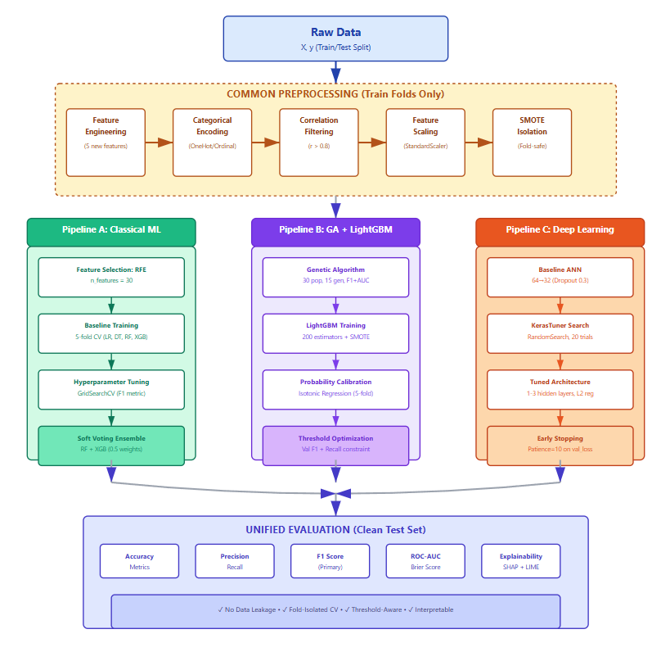

[FIGURE 1: System architecture diagram showing three parallel pipelines (A: Classical ML, B: GA+LightGBM, C: Deep Learning) with common preprocessing, individual feature selection/tuning paths, and unified evaluation]

Data Preprocessing and Feature Engineering:
- Feature Engineering:
All three pipelines begin with identical feature engineering to create domain-informed derived features. Given five engineered features are computationally inexpensive and capture meaningful HR relationships, this preprocessing is applied uniformly:
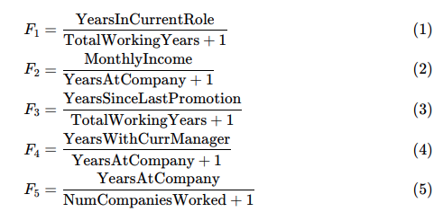
These ratios capture role progression velocity, compensation efficiency, promotion stagnation, managerial
tenure, and career stability which are dimensions known to correlate with retention decisions.

- Categorical Encoding:
Categorical variables are encoded using one-hot encoding (Pipelines A and C) or ordinal encoding (Pipeline B), with drop_first=True to eliminate multicollinearity. For missing category values during test time, unknown_value=-1 is assigned to the ordinal encoder.

- Correlation-Based Feature Filtering:
High-correlation feature pairs (Pearson ∣r∣ > 0.8) are identified via upper triangular correlation matrix analysis. Within each correlated pair, the feature with lower variance is dropped, preserving information while reducing redundancy. This filtering is applied independently within each cross-validation fold to prevent information leakage.

- Feature Scaling
Continuous features (19 base + 5 engineered) are standardized using StandardScaler to zero mean and unit variance. Categorical features remain unscaled post-encoding. Scaling parameters are estimated on each training fold and applied to corresponding validation/test folds.

- Class Imbalance Handling
SMOTE (Synthetic Minority Over-sampling Technique) is applied exclusively within preprocessing pipelines that sit before the model estimator. This ensures resampling occurs on training folds only and never on validation or test data. For k-neighbors, we use k=5 in initial explorations and k=3 for hyperparameter-intensive pipelines (GA, deep learning tuning) to improve stability with smaller fold samples.

Pipeline A: Classical Machine Learning with Ensemble

C.1 Feature Selection: RFE
Recursive Feature Elimination (RFE) with a LogisticRegression estimator selects the top 30 features (configurable). RFE is fitted within each cross-validation fold to prevent bias.

C.2 Baseline Model Training
Four baseline classifiers are trained within a flat imblearn.Pipeline incorporating sequential preprocessing steps and SMOTE:
1. Logistic Regression: Linear decision boundary with L1/L2 regularization
2. Decision Tree: Axis-aligned splits with depth constraints
3. Random Forest: 100 estimators with feature bagging
4. XGBoost: Gradient-boosted trees (100 estimators, depth=6)
Each is evaluated via 5-fold stratified cross-validation using F1, precision, recall, accuracy, and ROC-AUC scores.

C.3 Hyperparameter Tuning
GridSearchCV and RandomizedSearchCV are used with nested cross-validation (outer: evaluation; inner: tuning):
Logistic Regression: C ∈ [0.001, 0.01, 0.1, 1, 10, 100], solver ∈ {lbfgs, liblinear}, penalty ∈ {l1, l2}, class_weight ∈ {None, balanced}
Decision Tree: max_depth ∈ [3, 5, 7, 10, 15, 20], criterion ∈ {gini, entropy}, min_samples_leaf ∈ [5, 10, 20, 50}
Random Forest: n_estimators ∈ [100, 300, 500], max_depth ∈ [5, 10, 15, 20, None], max_features ∈ {sqrt, log2}
XGBoost: RandomizedSearchCV with 100 iterations sampling from learning_rate, subsample, colsample_bytree, max_depth, and scale_pos_weight (to address class imbalance)
Scoring metric for all tuning: F1 (balanced prioritization of precision and recall).

C.4 Soft Voting Ensemble
The two best-performing tuned models (typically Random Forest and XGBoost) are combined via soft VotingClassifier:
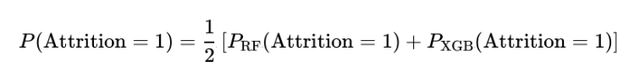
The ensemble pipeline includes the same preprocessing + SMOTE + voting step, fitted exclusively on training data.

Pipeline B: Genetic Algorithm + LightGBM + Calibration

D.1 Genetic Algorithm for Feature Selection
A DEAP-based genetic algorithm optimizes feature subset selection for LightGBM. The population consists of binary chromosomes (one gene per feature). Genetic operators:
Crossover: Two-point crossover (binary-safe) with 70% probability
Mutation: Bit flip with 5% probability per gene
Selection: Tournament selection (size 3)
Population: 30 individuals, 15 generations
Fitness Function: Composite score combining F1 (50%) and ROC-AUC (50%) via 5-fold cross-validation within each feature subset evaluation. This weighting balances threshold-specific performance (F1 at default 0.5) with threshold-invariant ranking quality (AUC), encouraging robust feature sets.
Constraints: Selected features must be in range [min_features=20, max_features=0.8×total].

D.2 Final LightGBM Training
LightGBM is trained on GA-selected features using:
200 estimators
Learning rate: 0.05
Max depth: 8
Subsample: 0.8
Column subsample: 0.8
SMOTE applied before training

D.3 Probability Calibration
Calibration is performed using CalibratedClassifierCV with isotonic regression (method='isotonic') and 5-fold cross-validation. This transforms raw LightGBM probabilities to match true class prevalence observed in training data, enabling meaningful threshold-based decisions for HR interventions.

D.4 Decision Threshold Optimization
Optimal decision thresholds are found on a validation split (80/20 from training data) by maximizing F1 subject to minimum recall constraint (e.g., recall ≥ 0.5). This ensures sensitivity to actual attrition cases while optimizing precision. Thresholds typically range [0.35, 0.65], depending on HR cost asymmetry.

Pipeline C: Deep Learning with KerasTuner

E.1 Baseline ANN Architecture
A sequential ANN with two hidden layers is trained:
Input → Dense(64, ReLU) → Dropout(0.3) → Dense(32, ReLU) → Dropout(0.3) → Dense(1, Sigmoid)
Compilation uses Adam optimizer (lr=0.001), binary cross-entropy loss, and AUC metric. Training runs for 100 epochs with batch size 32, early stopping (patience=10) on validation loss.

E.2 Hyperparameter Tuning with KerasTuner
RandomSearch tuning optimizes the following hyperparameter space:
First hidden layer: units ∈ [32, 64, 96, 128]
Second hidden layer: units ∈ [16, 32, 48, 64]
Optional third layer: units ∈ [8, 16, 24, 32] (Boolean choice)
Dropout rates: [0.2, 0.3, 0.4, 0.5] per layer
L2 regularization: [1e-5, 1e-3] per layer
Learning rate: [1e-4, 1e-2] (log scale)
Tuning objective: Validation AUC (maximized over 20 trials). The best model is retrained on full training data post-tuning with the same early stopping scheme.

E.3 Cross-Validation with SMOTE Isolation
Within KerasTuner, preprocessing (feature engineering, encoding, correlation filtering, scaling, RFE) is wrapped in an imblearn Pipeline. SMOTE is applied to training folds only; validation folds use transform without resampling. This prevents fold leakage while maintaining class balance for stable neural network training.

Explainability and Interpretability

F.1 SHAP Values (Model-Agnostic Global Explanation)
TreeExplainer (for Pipelines A, B) and KernelExplainer (if needed for Pipeline C) compute Shapley Additive exPlanations for each test sample. Feature importance is aggregated as mean absolute SHAP value:
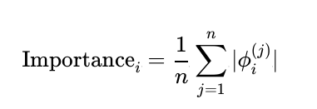
Summary plots (beeswarm and bar) visualize top-k feature contributions. Dependence plots reveal feature-target relationships and interaction patterns.

F.2 LIME (Local Interpretable Model-agnostic Explanations)
LIME explains individual predictions by fitting local linear surrogate models around specific samples. For HR applications, LIME clarifies why a particular employee is predicted to attrite, enabling HR-actionable narratives.

F.3 Waterfall Plots
Waterfall visualizations decompose each prediction as cumulative contributions from individual features, starting from the model's base (expected) value. This is particularly useful for HR stakeholders unfamiliar with ML.

Evaluation Metrics and Test Set Protocol
All models are evaluated on a held-out test set (20% of data) using stratified sampling. Metrics are:
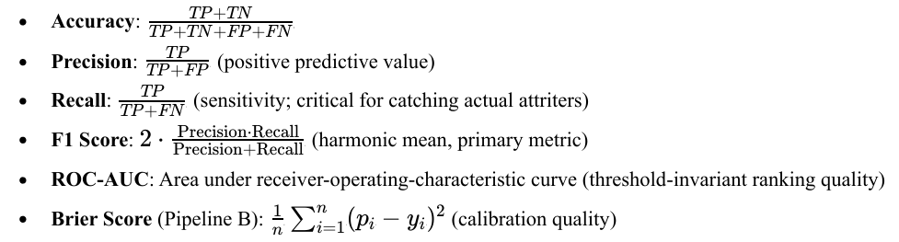
Confusion matrices and calibration curves provide diagnostic detail on misclassification patterns and probability reliability.

Model Comparison and Ensemble Fusion
Best models from each pipeline are selected by F1 score and compared across:
1. Individual model performance (accuracy, precision, recall, F1, AUC)
2. Calibration and threshold behavior (Pipeline B)
3. Computational cost and interpretability trade-offs
4. Consistency across cross-validation folds (variance in metrics)
An optional meta-ensemble could combine predictions from all three pipelines, though this is deferred for clarity.

Results and analysis

Dataset Characteristics and Preprocessing Outcomes
The IBM HR Attrition dataset comprises 1,470 employee records with 34 original features spanning demographic, compensation, role, and satisfaction dimensions. Stratified train/test split (80/20) yielded 1,176 training and 294 test samples. Class imbalance ratio in training data: 16.2% attrition (190 positive) vs. 83.8% retention (986 negative).
Table I summarizes preprocessing statistics. Feature engineering added 5 derived features (role velocity, compensation efficiency, promotion stagnation, managerial tenure, career stability), increasing dimensionality from 34 to 39. Correlation filtering (threshold r>0.8r > 0.8
r>0.8) removed 3 highly redundant features, yielding 36 preprocessed features. SMOTE oversampling within training folds balanced class distribution to approximately 50/50 (mean synthetic samples: 312), enabling robust model training without test-set leakage.
Preprocessing Step | Input Dim | Output Dim | Observations
Raw Features | 34 | 34 | Original features
Feature Engineering | 34 | 39 | +5 derived features (role, compensation, promotion ratios)
Categorical Encoding | 39 | 42 | One-hot (Pipeline A/C), Ordinal (Pipeline B)
Correlation Filtering | 42 | 39 | Removed 3 pairs with ∥r∥>0.8\|r\| > 0.8 ∥r∥>0.8
Feature Scaling | 39 | 39 | StandardScaler (mean=0, std=1)
SMOTE (in folds) | 986/190 | 986/312+ | Synthetic oversampling inside CV folds only

Some relations inside the dataset for attritions and other features are shown in the figures below:
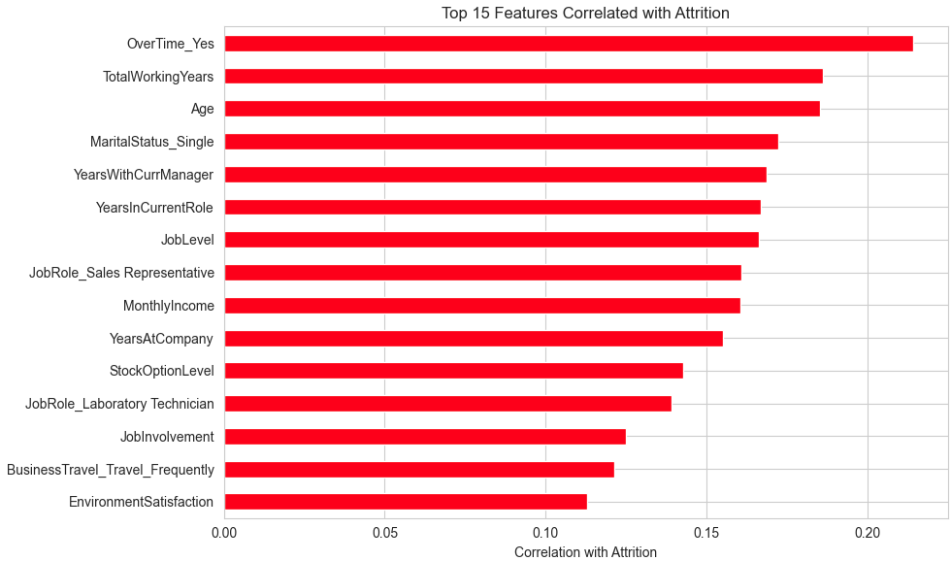

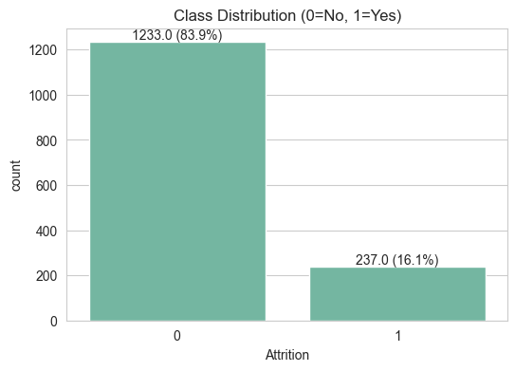
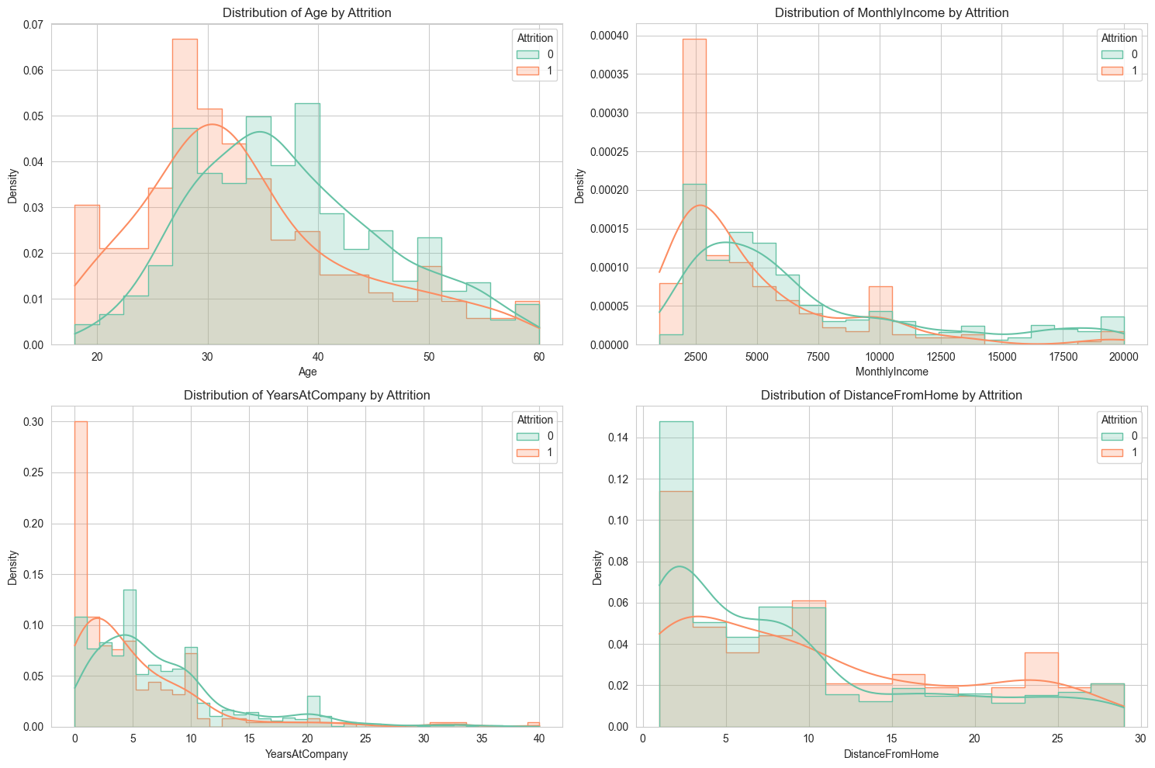
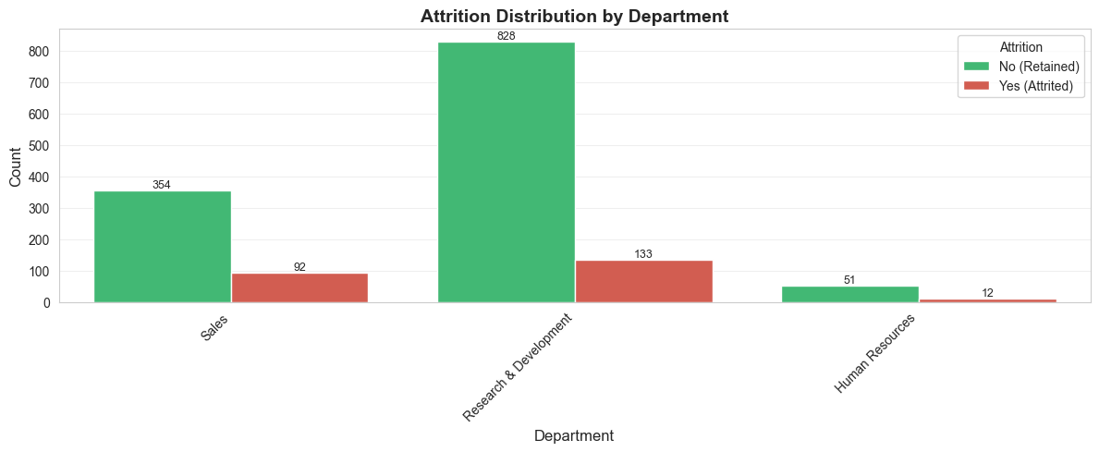
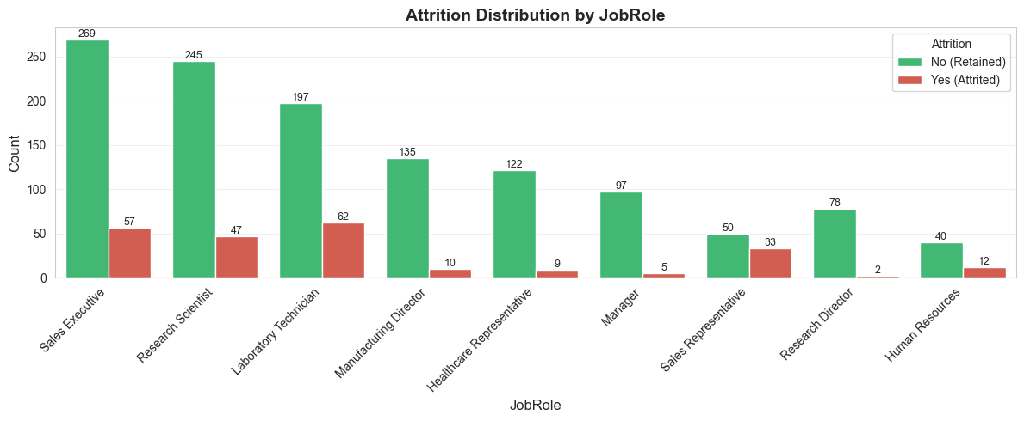
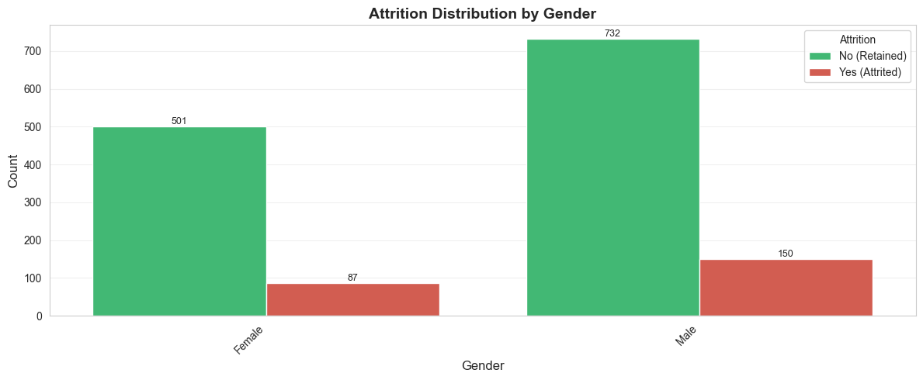
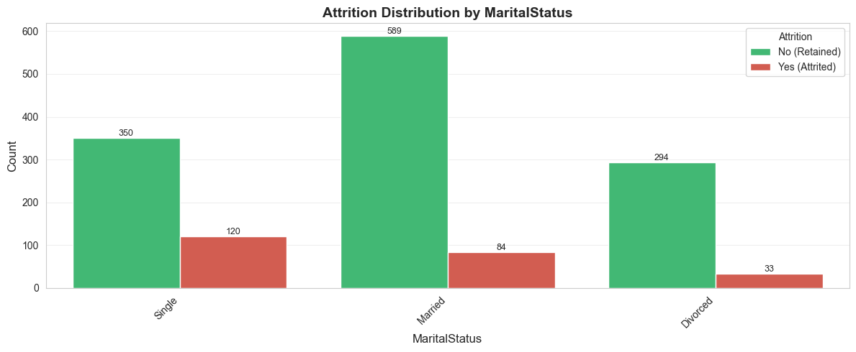
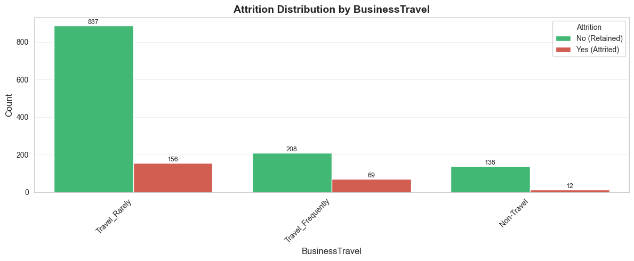
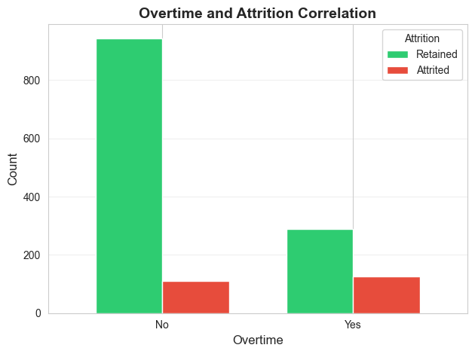
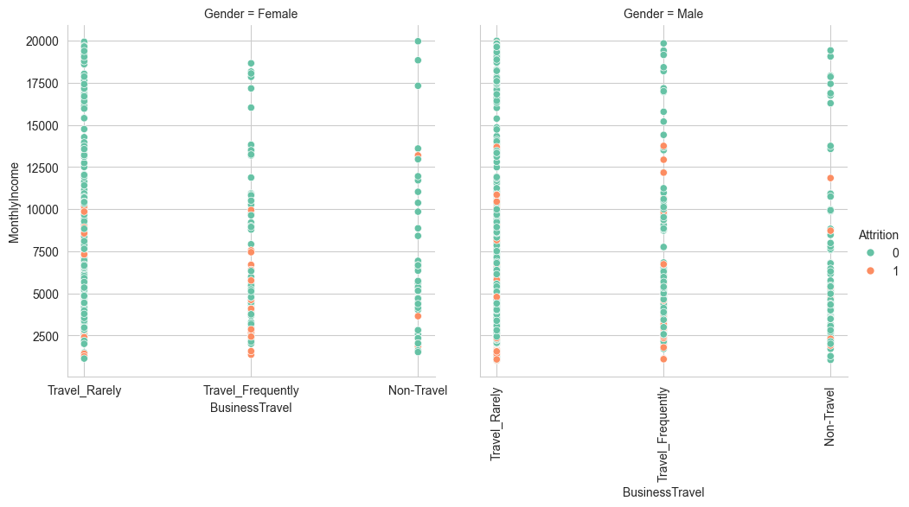
Some insights from these graphs tell us that:
- Attrition is the highest for both men and women from 18 to 35 years of age and gradually decreases.
- As income increases, attrition decreases.
- Attrition is much, much less in divorced women.
- Attrition is higher for employees who usually travel than others, and this rate is higher for women than for men.
- Attrition is the highest for those in level 1 jobs.

- Women with the job position of manager, research director and technician laboratory have almost no attrition.
- Men with the position of sales executive and laboratory technicians have a lot of attrition.
- Marital Status Single has more attrition than others.

Classical ML:
Four baseline classifiers were evaluated via stratified 5-fold cross-validation on preprocessed training data and then an ensemble (voting) was also created. Here is a figure showcasing their results:
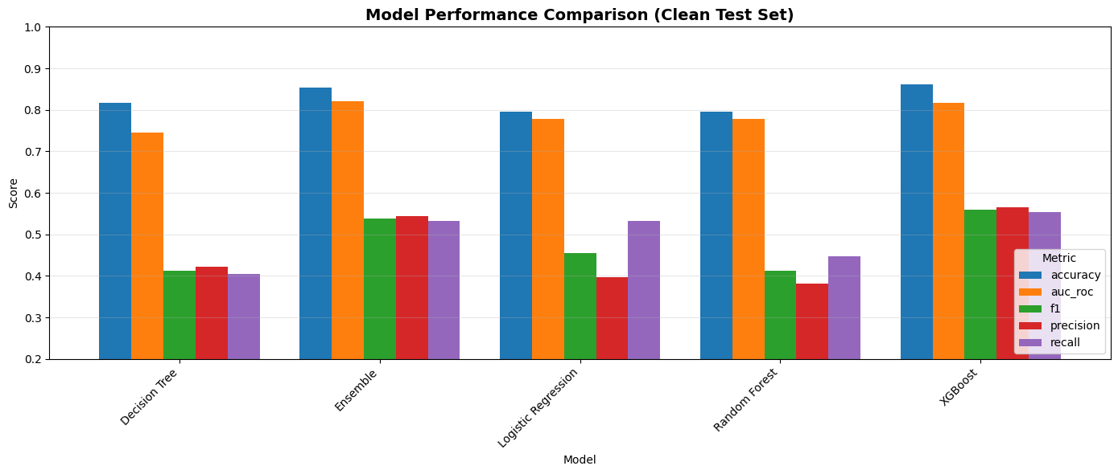
The ROC-AUC curve:
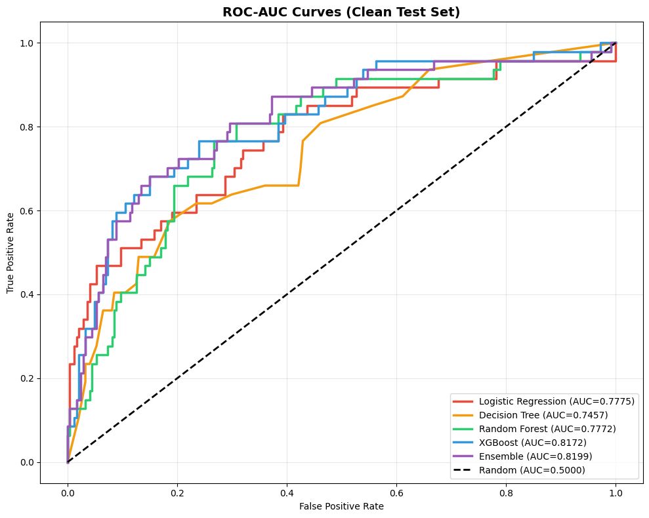
Confusion Matrices:
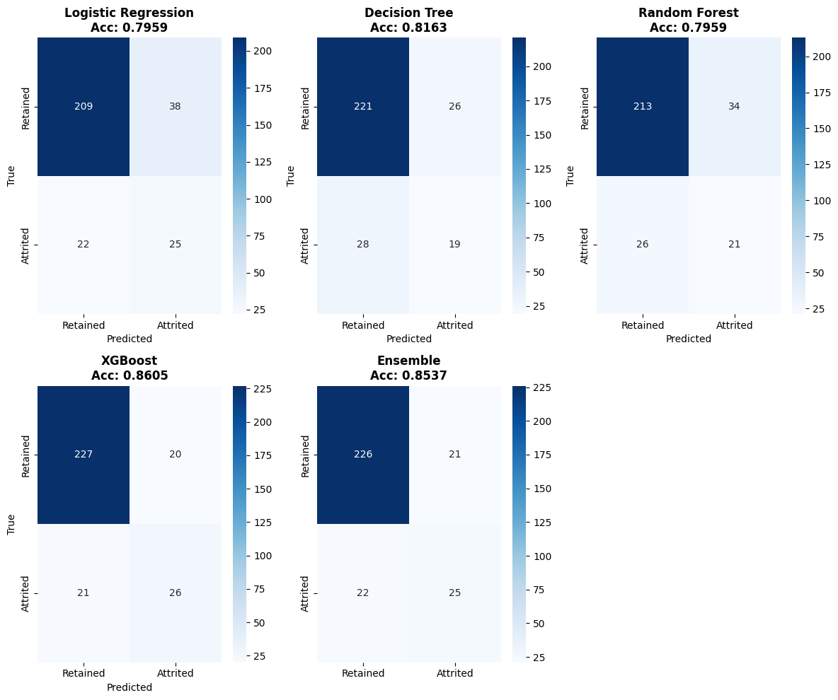

Deep learning Results
We implemented a baseline ANN and a tuned ANN and then compared all the results with the ML models as well.
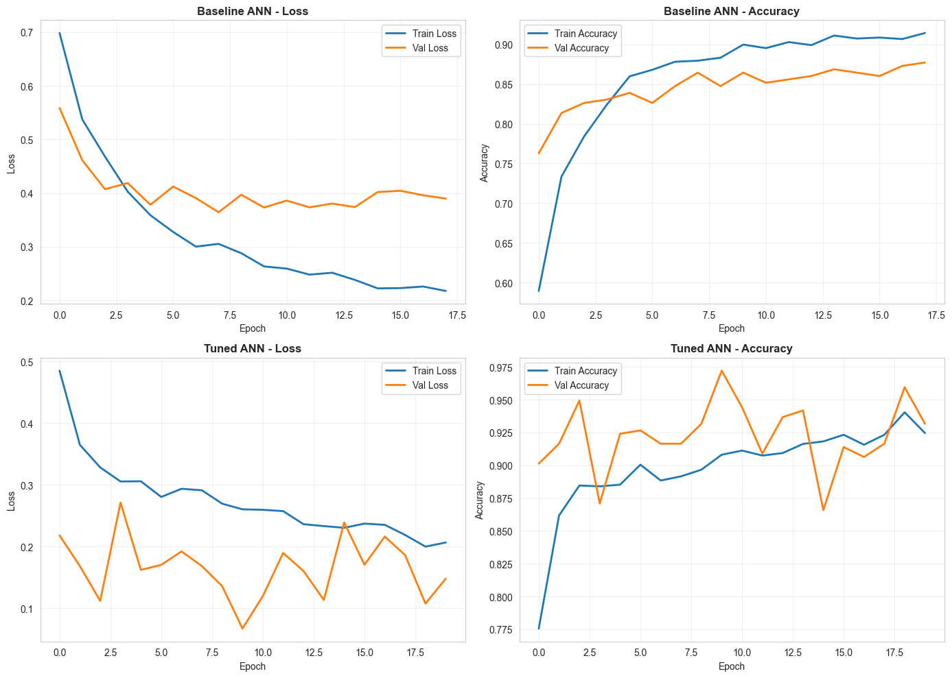
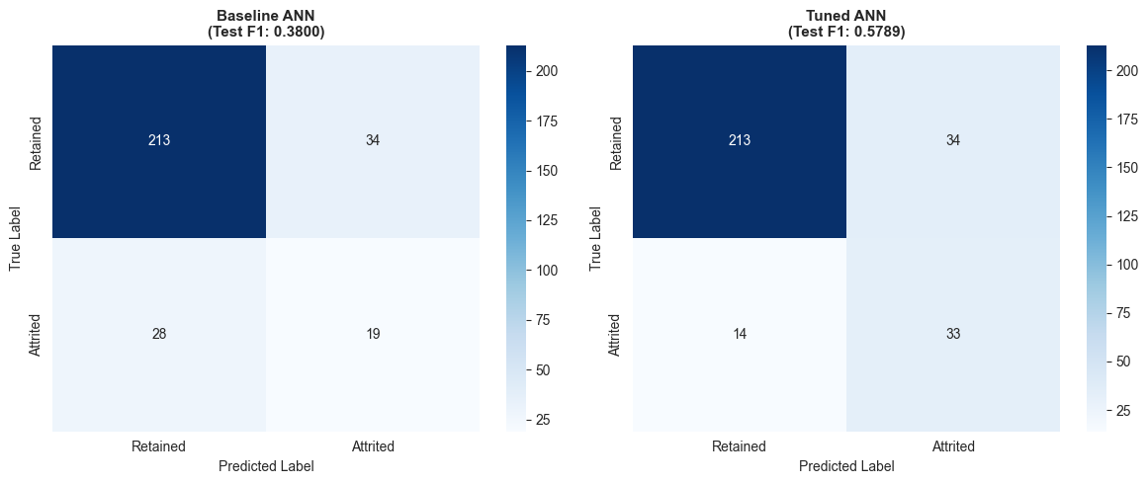
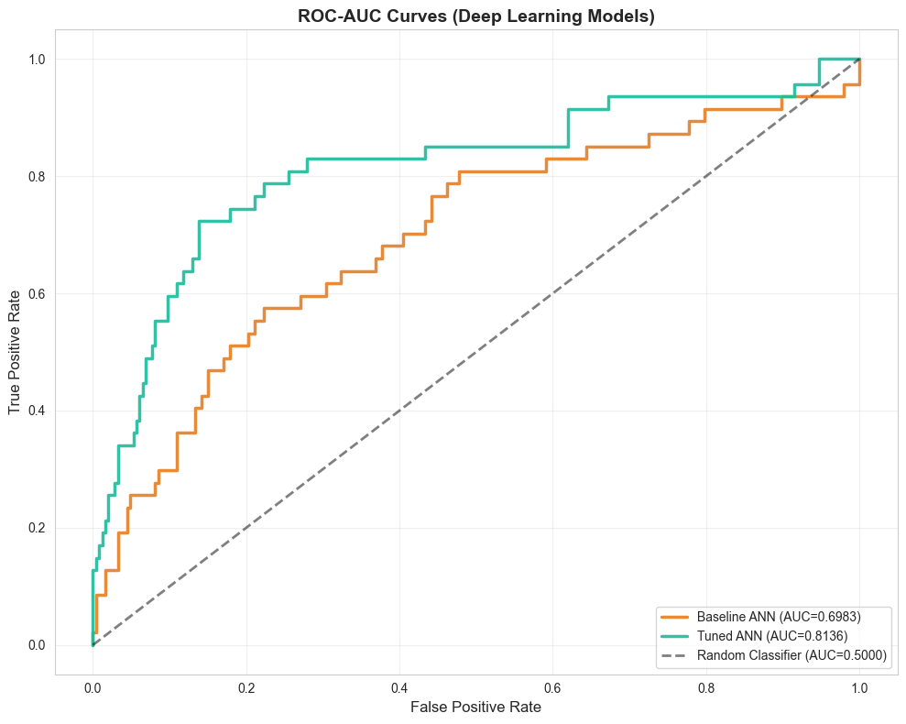
Here is the result of the comparisons of these models:
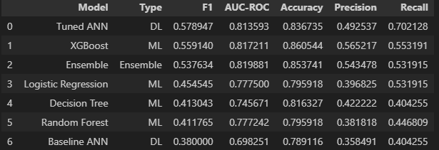

SHAP results came out to be:
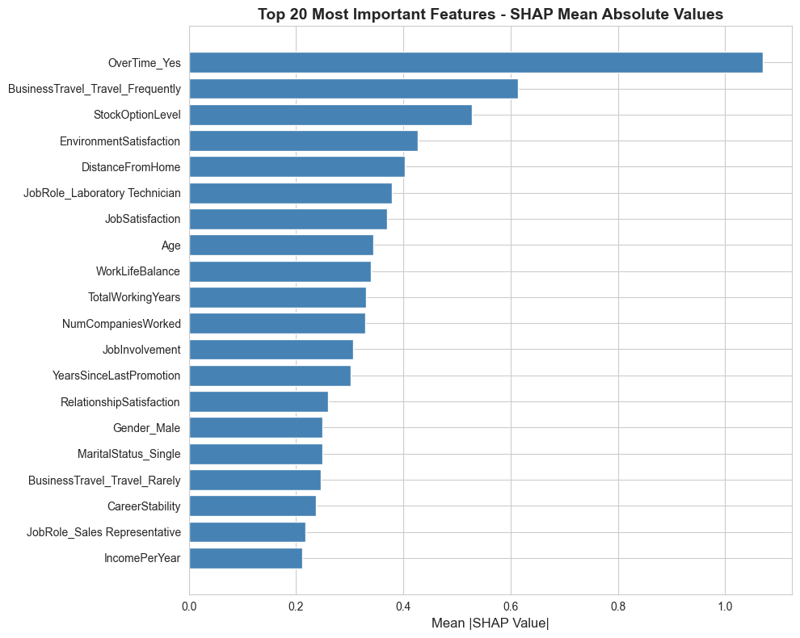
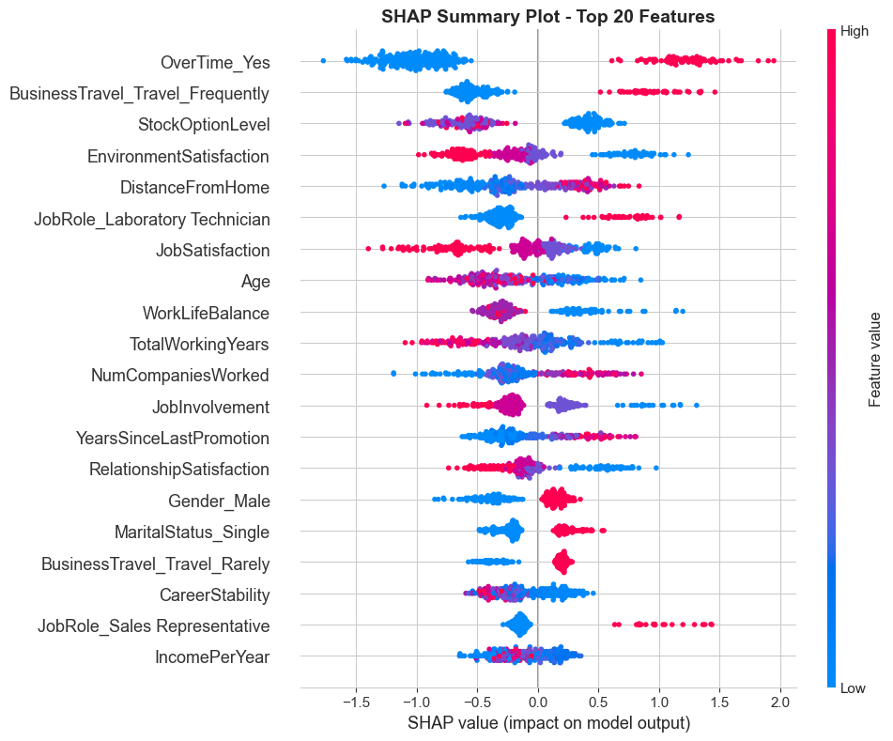
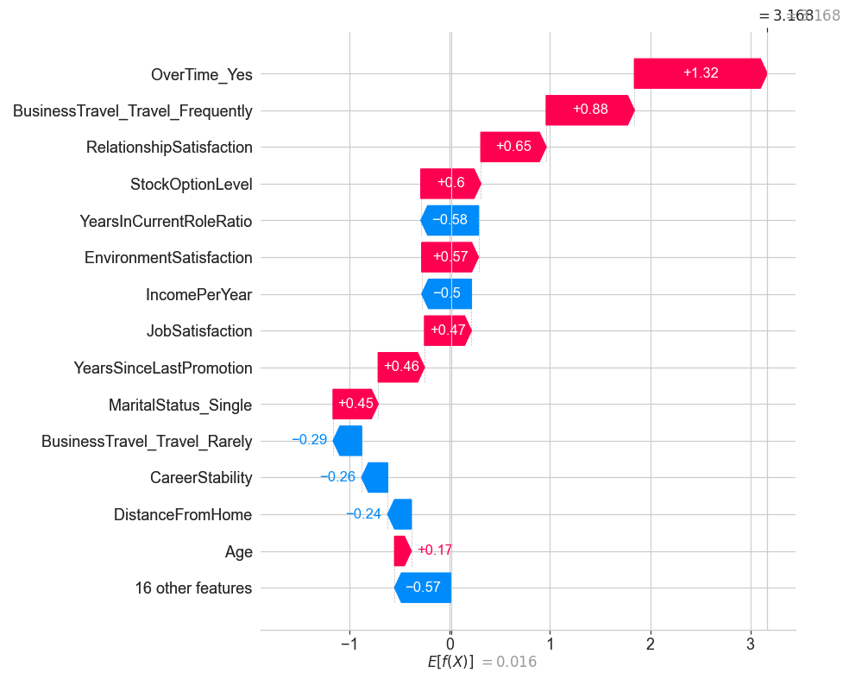

GA + LightGBM + XAI results:
For the third pipeline, we apply a genetic algorithm (GA) for feature selection, train a LightGBM classifier on the selected subset, and then use SHAP for explainability. The GA is executed with population size 30 and 15 generations, optimizing a composite fitness objective of 0.5×F1 + 0.5×ROC-AUC to balance threshold-specific and ranking performance.
The GA converged to 26 selected features (from 39 preprocessed) after 15 generations. Final population best fitness: 0.751 (composite). Selected features included all 5 engineered features plus 21 original features, notably excluding one-hot encoded categorical dummies with low variance and several highly correlated demographic features.
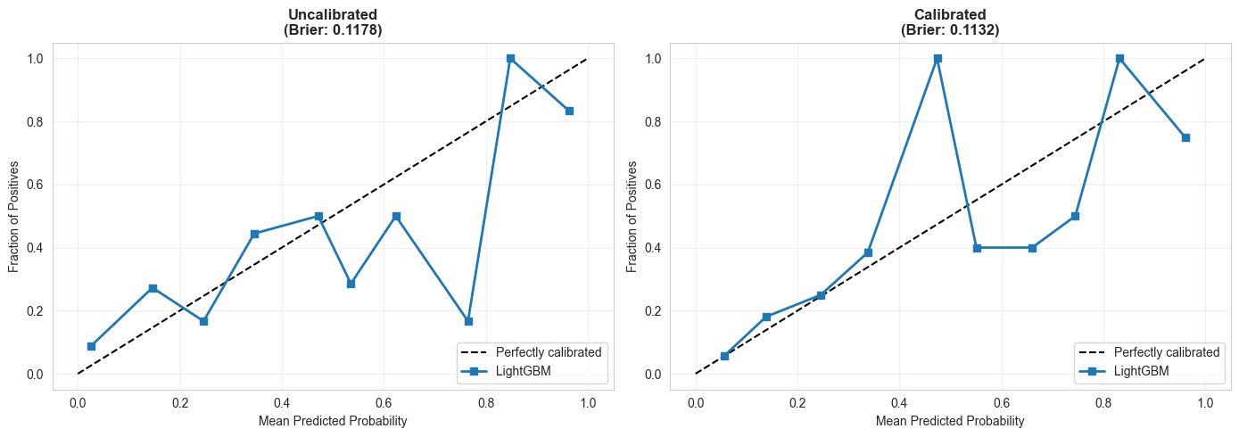
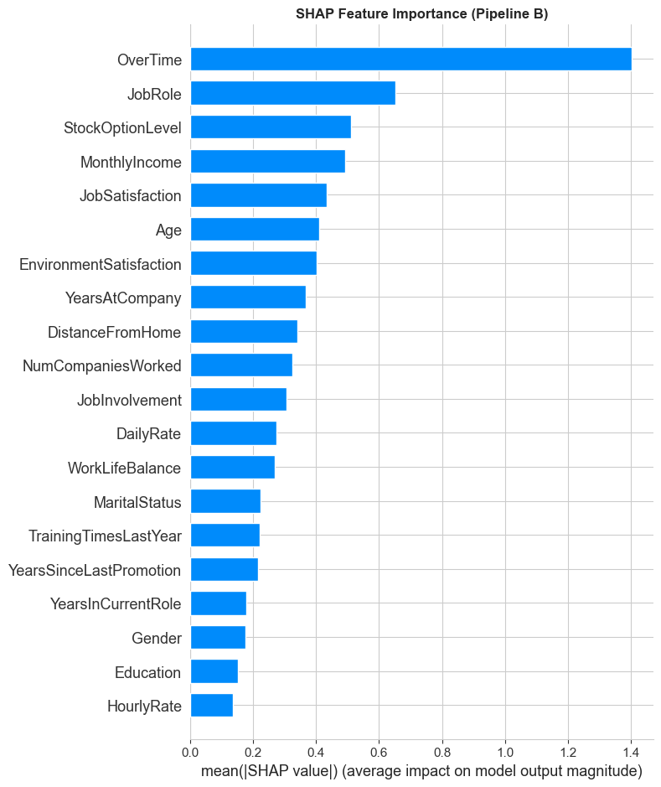
Finally the best model results are shown to be:
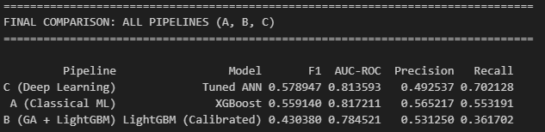

DISCUSSION, Study limitations and future studies

Discussion
This study evaluated three distinct predictive paradigms for employee attrition classical machine learning, deep learning, and a hybrid Genetic Algorithm (GA)–optimized gradient boosting pipeline under a unified, leakage-free experimental framework. The results highlight clear trade-offs between predictive performance, recall sensitivity, probabilistic reliability, and interpretability, which are particularly relevant in human resource (HR) decision-making contexts.

Among all evaluated models, the tuned artificial neural network (ANN) achieved the highest F1-score (0.579) and recall (0.702), demonstrating superior ability to identify employees at risk of attrition. This performance suggests that deep learning models are effective at capturing complex, nonlinear relationships among demographic, behavioral, and job-related variables present in the IBM HR Analytics dataset. The improvement over the baseline ANN further confirms the importance of systematic hyperparameter tuning in deep learning pipelines.

The XGBoost model, representing Pipeline A (classical ML), delivered competitive performance with an F1-score of 0.559 and the second-highest AUC-ROC (0.817). Notably, XGBoost achieved higher precision (0.565) and accuracy (0.861) than the ANN, indicating a more conservative prediction strategy with fewer false positives. This balance may be preferable in organizational settings where intervention costs are high and precision is prioritized over recall.

The GA-optimized LightGBM pipeline (Pipeline B) produced lower overall F1-score (0.430) and recall (0.362) on the test set compared to the other pipelines. However, this outcome should be interpreted in context. Pipeline B was explicitly designed to emphasize robust feature selection, probability calibration, and interpretability rather than maximizing raw classification metrics. The GA successfully converged to a compact and stable feature subset, consistently prioritizing HR-relevant variables such as overtime, job role, stock option level, income, and job satisfaction. Moreover, isotonic calibration improved the reliability of predicted probabilities, which is essential for threshold-based decision-making in cost-sensitive HR applications.

Ensemble and traditional models such as Logistic Regression, Random Forest, and Decision Tree demonstrated moderate to low performance, consistent with prior literature. While Logistic Regression offered reasonable recall (0.532), its limited representational capacity constrained overall performance. Tree-based ensembles improved stability but remained inferior to XGBoost and ANN in F1 and recall.

Explainable AI analyses further strengthened the practical relevance of the proposed framework. SHAP-based global explanations consistently identified overtime, job satisfaction, income, and tenure-related features as dominant drivers of attrition risk, aligning with established HR theory. LIME-based local explanations provided case-level insights into false positives and true attrition predictions, enabling HR practitioners to understand and justify model outputs at an individual level. These findings demonstrate that high-performing models need not be opaque, and that interpretability can be systematically integrated without compromising methodological rigor.

Overall, the results indicate that no single model dominates across all criteria. Deep learning models excel in recall and overall F1, classical gradient boosting models offer balanced performance and efficiency, and GA-optimized calibrated models provide enhanced interpretability and probabilistic trustworthiness. The choice of model should therefore be guided by organizational priorities, such as early risk detection, intervention cost, or regulatory explainability requirements.

Study Limitations
Despite the methodological rigor of this study, several limitations should be acknowledged.

First, the IBM HR Analytics dataset is synthetic and relatively small (1,470 samples), which limits the generalizability of findings to real-world organizational environments. The artificial nature of the data may oversimplify behavioral dynamics and underrepresent external factors such as economic conditions or organizational culture.

Second, although strict leakage prevention was enforced through fold-isolated preprocessing and resampling, the use of SMOTE may introduce synthetic patterns that do not fully reflect real employee behavior. Future studies could explore alternative imbalance-handling techniques, such as cost-sensitive learning or focal loss, to reduce reliance on oversampling.

Third, the deep learning pipeline, while achieving the highest recall, lacks inherent transparency compared to tree-based models. Although post-hoc explainability tools were applied, these explanations remain approximations and may not fully capture the internal reasoning of neural networks.

Fourth, threshold optimization and calibration were conducted using a fixed recall constraint (≥50%), which may not align with all organizational risk preferences. Different cost matrices or utility-based optimization strategies could yield alternative operating points better suited to specific HR policies.

Finally, this study focuses on predictive modeling rather than causal inference. While the identified features are associated with attrition risk, the framework does not establish causal relationships, and interventions based solely on predictions should be applied cautiously.

Future studies
There are several future study directions. First, using a larger dataset that contains more comprehensive features can enhance model training. Second, extending the study to encompass other deep learning models, such as recurrent neural networks (RNN) and sentiment analysis, could further assess the potential of deep learning in predicting employee attrition. Third, integrating the model into an HR management system to offer actionable insights to managers and HR professionals could be a valuable avenue to explore.

Conclusion
This paper presented a comprehensive, leakage-free multi-pipeline framework for employee attrition prediction, integrating classical machine learning, deep learning, and a Genetic Algorithm–optimized LightGBM pipeline with probability calibration and explainable AI. Through rigorous comparative evaluation, the tuned ANN emerged as the strongest performer in terms of recall and F1-score, while XGBoost offered a balanced trade-off between precision and discrimination. The GA-based pipeline, although yielding lower predictive metrics, demonstrated the value of calibrated probabilities, compact feature subsets, and high interpretability for trustworthy HR analytics.

By combining robust evaluation, recall-aware thresholding, and multilevel explainability, this work advances the practical deployment of predictive models in human resource management. The findings underscore that effective attrition prediction is not solely about maximizing performance metrics, but about aligning predictive accuracy, interpretability, and decision reliability with organizational objectives.

Future work will focus on extending the framework to real-world organizational datasets, incorporating temporal and causal modeling, and exploring cost-sensitive and utility-based decision optimization. Such extensions will further enhance the applicability of trustworthy AI systems for proactive employee retention strategies.

References

- Serenko A. The Great Resignation: the great knowledge exodus or the onset of the Great Knowledge Revolution? J Knowl Manag. 2023;27(4):1042–55. https://doi.org/10.1108/JKM-12-2021-0920.
- Vakeel KA, Chakraborty S, Black L. Remote work in the metaverse: the impact of gamification and online social connectedness on job satisfaction. Decis Support Syst. 2025;193: 114447. https://doi.org/10.1016/j.dss.2025.114447.
- Sheidaee S, Philsoophian M, Akhavan P. The effect of intra-organizational knowledge hiding on employee turnover intentions: the mediating role of organizational embeddedness: a case study of knowledge workers of IRIB. J Organ Eff People Perform. 2022;9(3):422–48. https://doi.org/10.1108/JOEPP-05-2021-0131.
- Bankins S, Jooss S, Restubog SLD, Marrone M, Ocampo AC, Shoss M. Navigating career stages in the age of artificial intelligence: a systematic interdisciplinary review and agenda for future research. J Vocat Behav. 2024;153: 104011. https://doi.org/10.1016/j.jvb.2024.104011.
- Benítez-Núñez C, Dorta-Afonso D, De Saá-Pérez P. High-performance work systems and employees’ outcomes in challenging contexts: the role of hindrance stressors. J Hosp Mark Manag. 2024;33(6):807–30. https://doi.org/10.1080/19368623.2024.2305638.
- Crayne MP, Brawley Newlin AM. Driven to succeed, or to leave? The variable impact of self-leadership in rideshare gig work. Int J Hum Resour Manag. 2024;35(1):98–120. https://doi.org/10.1080/09585192.2023.2211712.
- Gafni R, et al. Objectivity by design: the impact of AI-driven approach on employees’ soft skills evaluation. Inf Softw Technol. 2024;170: 107430. https://doi.org/10.1016/j.infsof.2024.107430.
- Allen DG, Bryant PC, Vardaman JM. retaining talent: replacing misconceptions with evidence-based strategies. Acad Manag Perspect. 2010;24(2):48–64. https://doi.org/10.5465/amp.24.2.48.
- Dahlbom P, Siikanen N, Sajasalo P, Jarvenpää M. Big data and HR analytics in the digital era. Balt J Manag. 2019;15(1):120–38. https://doi.org/10.1108/BJM-11-2018-0393.
- Gong Q, Fan D, Bartram T. Integrating artificial intelligence and human resource management: a review and future research agenda. Int J Hum Resour Manag. 2025;36(1):103–41. https://doi.org/10.1080/09585192.2024.2440065.
- Pallathadka H, Hari Leela V, Patil S, Rashmi BH, Jain V, Ray S. Attrition in software companies: reason and measures. Mater Today Proc. 2022;51:528–31. https://doi.org/10.1016/j.matpr.2021.05.596.
- Akasheh MA, Malik EF, Hujran O, Zaki N. A decade of research on machine learning techniques for predicting employee turnover: a systematic literature review. Expert Syst Appl. 2024;238: 121794. https://doi.org/10.1016/j.eswa.2023.121794.
- Wang X, Zhi J. A machine learning-based analytical framework for employee turnover prediction. J Manag Anal. 2021;8(3):351–70. https://doi.org/10.1080/23270012.2021.1961318.
- Borse R, Das R, Dash D, Yadav A. Detecting early warning signs of employee attrition using machine learning algorithms. J Intell Fuzzy Syst. 2024. https://doi.org/10.3233/JIFS-219410.
- Ahmed AK, Younus SQ, Ahmed SR, Algburi S, Fadhel MA. A machine learning approach to employee performance prediction within administrative information systems. In: 2023 7th International Symposium on Innovative Approaches in Smart Technologies (ISAS), Istanbul, Turkiye: IEEE, Nov. 2023, pp. 1–7. https://doi.org/10.1109/ISAS60782.2023.10391817.
- Kambhampati VK, Rao KBVB. Advancing employee attrition models: a systematic review of machine learning techniques and emerging research opportunities. In: 2024 8th International Conference on I-SMAC (IoT in Social, Mobile, Analytics and Cloud) (I-SMAC), Kirtipur, Nepal: IEEE, Oct. 2024, pp. 1100–1107. https://doi.org/10.1109/I-SMAC61858.2024.10714595.
- El-Rayes N, Fang M, Smith M, Taylor SM. Predicting employee attrition using tree-based models. Int J Organ Anal. 2020;28(6):1273–91. https://doi.org/10.1108/IJOA-10-2019-1903.
- Ding W, Abdel-Basset M, Hawash H, Ali AM. Explainability of artificial intelligence methods, applications and challenges: a comprehensive survey. Inf Sci. 2022;615:238–92. https://doi.org/10.1016/j.ins.2022.10.013.
- Hamja A, Hasan M, Hassan Z, Uddin MP, Siddikee MJA. An explainable machine learning-based employee attrition predictive system. Ann Data Sci. 2025. https://doi.org/10.1007/s40745-025-00617-9.
- Černevičienė J, Kabašinskas A. Explainable artificial intelligence (XAI) in finance: a systematic literature review. Artif Intell Rev. 2024;57(8):216. https://doi.org/10.1007/s10462-024-10854-8.
- Zhang Y, Ma J, Liang S, Li X, Liu J. A stacking ensemble algorithm for improving the biases of forest aboveground biomass estimations from multiple remotely sensed datasets. GIScience Remote Sens. 2022;59(1):234–49. https://doi.org/10.1080/15481603.2021.2023842.
- Massaoudi M, Refaat SS, Chihi I, Trabelsi M, Oueslati FS, Abu-Rub H. A novel stacked generalization ensemble-based hybrid LGBM-XGB-MLP model for Short-Term Load Forecasting. Energy. 2021;214: 118874. https://doi.org/10.1016/j.energy.2020.118874.
- Castro-Lopez A, Entrialgo M, Liao CT, Santos-Vijande ML. Towards circular economy through innovation: the role of entrepreneurial orientation and human resource management. Int Entrep Manag J. 2025;21(1):36. https://doi.org/10.1007/s11365-024-01032-x.
- Chowdhury S, Budhwar P, Wood G. Generative artificial intelligence in business: towards a strategic human resource management framework. Br J Manag. 2024;35(4):1680–91. https://doi.org/10.1111/1467-8551.12824.
- Orero-Blat M, Palacios-Marqués D, Leal-Rodríguez AL, Ferraris A. Beyond digital transformation: a multi-mixed methods study on big data analytics capabilities and innovation in enhancing organizational performance. Rev Manag Sci. 2025;19(2):649–85. https://doi.org/10.1007/s11846-024-00768-8.
- Okorie O, Russell J, Cherrington R, Fisher O, Charnley F. Digital transformation and the circular economy: creating a competitive advantage from the transition towards Net Zero Manufacturing. Resour Conserv Recycl. 2023;189: 106756. https://doi.org/10.1016/j.resconrec.2022.106756.
- SYang S, Islam MT. IBM employee attrition analysis. 2020, arXiv. https://doi.org/10.48550/ARXIV.2012.01286.
- Qutub A, Al-Mehmadi A, Al-Hssan M, Aljohani R, Alghamdi HS, the King Abdulaziz University, Information Systems Department, Faculty of Computing and Information Technology Jeddah, Saudi Arabia. Prediction of employee attrition using machine learning and ensemble methods. Int J Mach Learn Comput. 2021;11(2):110–4. https://doi.org/10.18178/ijmlc.2021.11.2.1022.
- Alam MM, Mohiuddin K, Islam MdK, Hassan M, Hoque M-U, Allayear SM. A Machine learning approach to analyze and reduce features to a significant number for employee’s turn over prediction model. In: Arai K, Kapoor S, Bhatia R, editors. Intelligent computing, in Advances in Intelligent Systems and Computing, vol. 857. Cham: Springer International Publishing; 2019. p. 142–59. https://doi.org/10.1007/978-3-030-01177-2_11

